ANUKEERTHANA S

Module 1 - Design Patterns and Principles
Exercise – 01
Implementing the Singleton Pattern
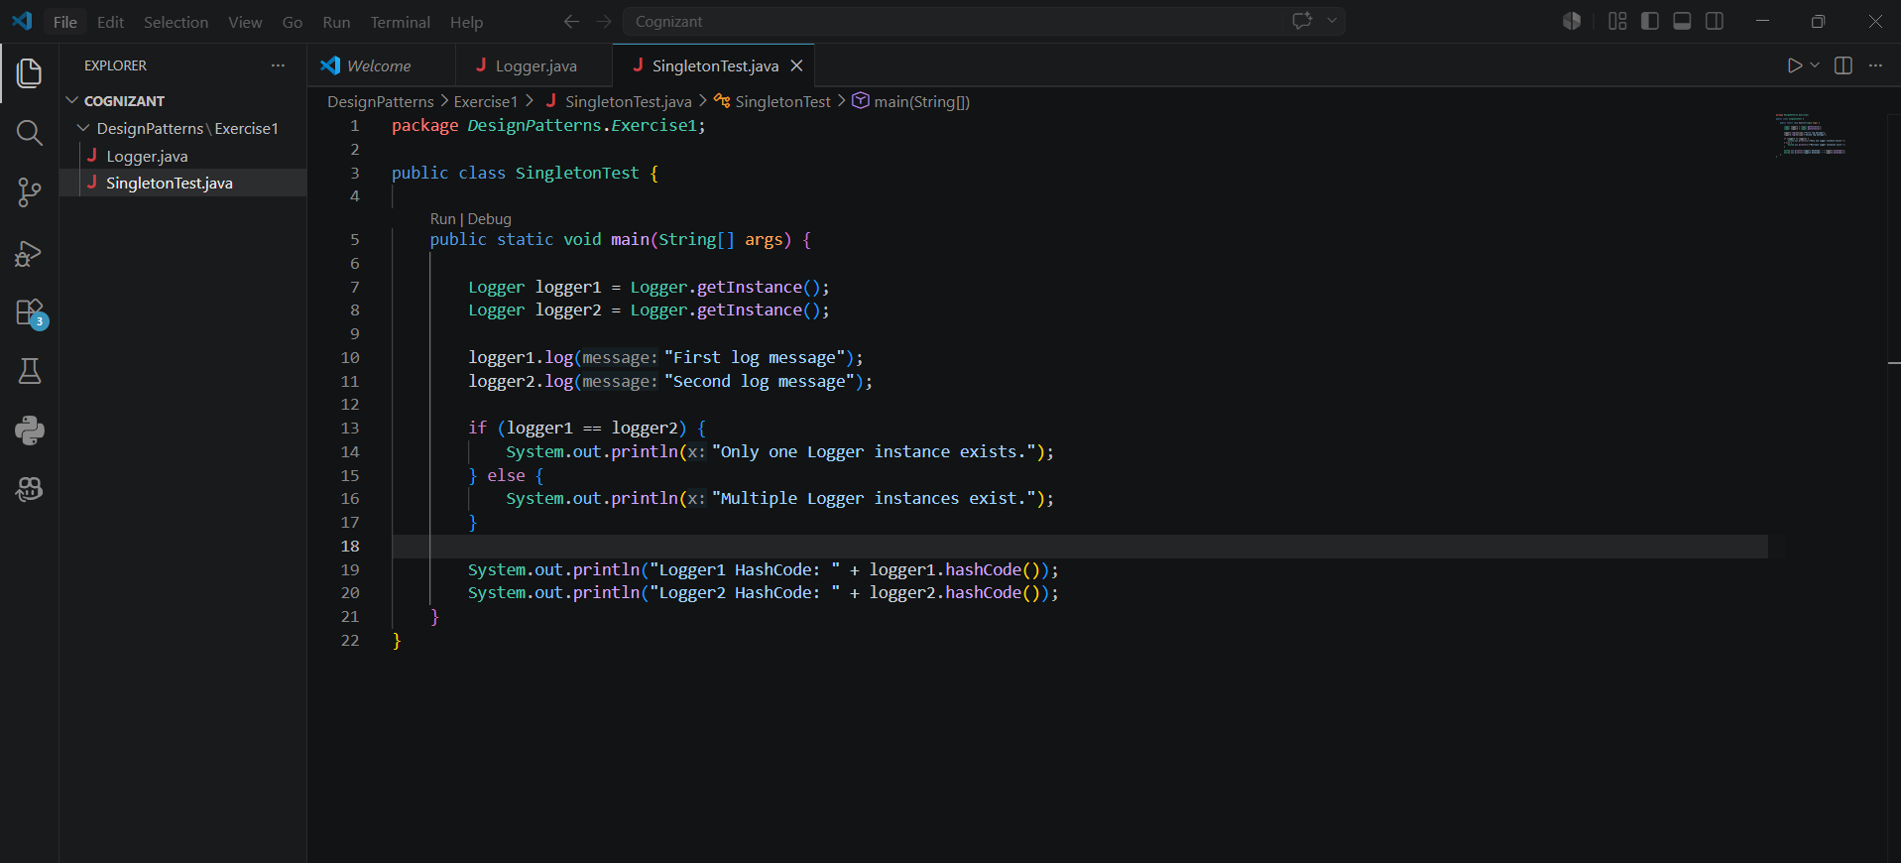

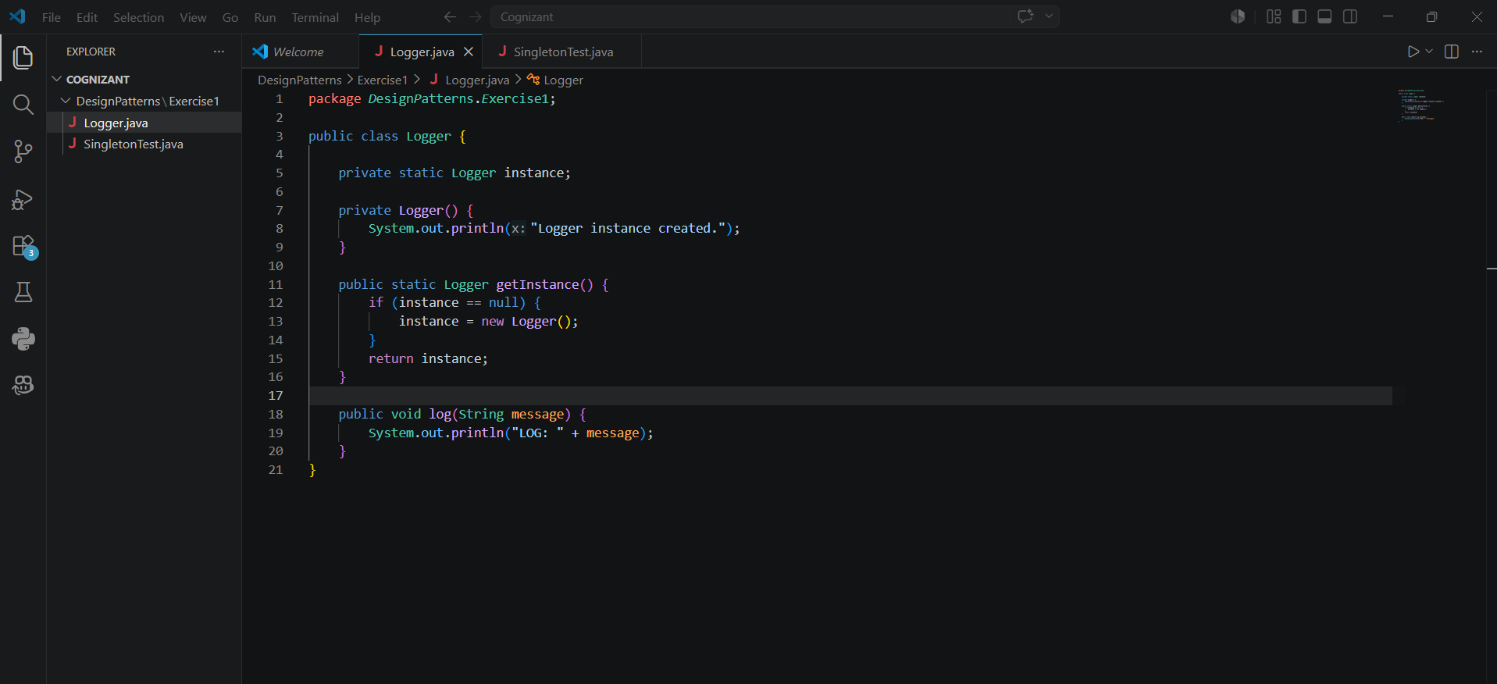
Output:
